

**MicroStrategy Quick Start Guide**

Copyright © 2018 Packt Publishing

All rights reserved. No part of this book may be reproduced, stored in a retrieval system, or transmitted in any form or by any means, without the prior written permission of the publisher, except in the case of brief quotations embedded in critical articles or reviews.

Every effort has been made in the preparation of this book to ensure the accuracy of the information presented. However, the information contained in this book is sold without warranty, either express or implied. Neither the author, nor Packt Publishing or its dealers and distributors, will be held liable for any damages caused or alleged to have been caused directly or indirectly by this book.

Packt Publishing has endeavored to provide trademark information about all of the companies and products mentioned in this book by the appropriate use of capitals. However, Packt Publishing cannot guarantee the accuracy of this information.

**Commissioning Editor:**Amey Varangaonkar  
**Acquisition Editor:** Reshma Raman  
**Content Development Editor:** Mohammed Yusuf Imaratwale  
**Technical Editor:** Jinesh Topiwala  
**Copy Editor:** Safis Editing  
**Project Coordinator:** Hardik Bhinde  
**Proofreader:** Safis Editing  
**Indexer:**Priyanka Dhadke  
**Graphics:**Jason Monteiro / Fernando Carlos Rivero Esqueda  
**Production Coordinator:**Aparna Bhagat

First published: September 2018

Production reference: 1270918

Published by Packt Publishing Ltd.  
Livery Place  
35 Livery Street  
Birmingham  
B3 2PB, UK.

ISBN 978-1-78913-624-1

[www.packtpub.com](http://www.packtpub.com/)

# Preface

Founded in 1989, MicroStrategy has been consistently recognized by Gartner as a business intelligence and analytics leader in technology. For almost 30 years, companies and organizations all over the world have trusted MicroStrategy to provide them with one of the best analytics, reporting, and mobile platforms. Nevertheless, the MicroStrategy platform can be daunting at first sight. The amount of concepts and information about MicroStrategy, combined with so many advanced features, a steep learning curve, costly courses, and limited literature, could discourage almost anyone. Moreover, the few books in the market are focused on advanced features and written for an audience with some degree of experience in business intelligence and reporting applications.

This book's objective is to help users and developers take the first step toward learning MicroStrategy by providing a good, solid foundation in a format that is easy to read and understand. The base concepts and skills learned by completing this book will aid the audience in moving to the next level in their knowledge of MicroStrategy.

# Who this book is for

This book is tailored toward business and information technology professionals with little or no experience in MicroStrategy, who want to learn the basics and start building reports right away. Also, this book can be easily adopted by professionals with experience in other business intelligence reporting platforms and tools.

# What this book covers

[Chapter 1](https://learning.oreilly.com/library/view/microstrategy-quick-start/9781789136241/19f2500c-9b42-40c7-afcb-a1a6924db287.xhtml), Architecture – Installing and Configuring MicroStrategy, introduces the reader to MicroStrategy, how its technology fits into the business intelligence spectra, and how it satisfies information demands for any organization. MicroStrategy architecture is presented and explained. Client applications, such as Developer and Web, are described, as well as server components. This chapter also describes how to install the MicroStrategy Intelligence Server, as well as the client tools used to build and maintain MicroStrategy Reports and analytics objects.

[Chapter 2](https://learning.oreilly.com/library/view/microstrategy-quick-start/9781789136241/fd4af412-abaf-48a5-b2d6-35619439116e.xhtml), Project Design – Creating Your Project Foundation, teaches the reader about MicroStrategy Objects, specifically about Schema Objects, which are used to create an abstraction or model of an analytical database or data warehouse. These objects serve as the foundation for the MicroStrategy Project. Each object is described and explained: what it its main purpose; how to build it, in terms of what its components are; and where it can be reused.

[Chapter 3](https://learning.oreilly.com/library/view/microstrategy-quick-start/9781789136241/4c09a3f2-6bed-4926-8cd3-480d5b9f9793.xhtml), Basic Reporting – Building Your First Reports, introduces to the reader the Public or Application Objects and how these objects are built from Schema Objects. The first reporting objects, such as Templates, Filters, and Metrics, are described and explained. At the end of the chapter, several Report manipulations are described.

[Chapter 4](https://learning.oreilly.com/library/view/microstrategy-quick-start/9781789136241/a9f0f9b0-f8bf-4689-aef9-e0f8d002b291.xhtml), Advanced Reporting – Interacting with and Improving Your Reports, continues to introduce new Public Objects to the reader; this time,  they are objects that will allow them to step up their analysis, flexibility, and performance. Intelligent Cubes are discussed and explained as a way to publish information so that MicroStrategy reporting applications can consume it.

[Chapter 5](https://learning.oreilly.com/library/view/microstrategy-quick-start/9781789136241/649fcb73-c184-421f-8c88-cfd90e5f4090.xhtml), Dashboarding – Creating Visual Reporting, covers visual information and dashboarding. It shows the reader how to import a data source and then create a Dashboard using Public Objects for enterprise-certified reporting, or to create a web Dashboard using self-service tools.

[Chapter 6](https://learning.oreilly.com/library/view/microstrategy-quick-start/9781789136241/fc2effe1-1dd1-406c-94d4-4bc6d06b96ae.xhtml), Security – Managing Your Users and Their Access, introduces Configuration Objects to the reader, and covers the main security levels in MicroStrategy. Some of these objects allow administrators to set up security profiles and permissions to access objects and to create Users and Groups.

[Chapter 7](https://learning.oreilly.com/library/view/microstrategy-quick-start/9781789136241/aac45770-f3d9-4af3-913d-55f7105d3290.xhtml), Administration – Maintaining and Monitoring your Project, expands the knowledge about other Configuration Objects describing those which allow system administrators to perform tasks such as establishing database connectivity and scheduling data refreshes for their Reports and Intelligent Cubes. Then, the main system monitors are presented and described. Finally, three Administrative client tools are described: Object Manager, Command Manager Integrity Manager.

[Appendix](https://learning.oreilly.com/library/view/microstrategy-quick-start/9781789136241/ebf7660d-dedf-404f-8f85-3e5f2b43049a.xhtml), Quick Reference Tables by Object Type, is a collection of all the quick reference tables used throughout the book by object type, for readers to reference.

# To get the most out of this book

This book requires a general understanding of application software and common graphical user interface applications, such as Windows Explorer. In addition, it is assumed that the reader understands basic business intelligence concepts and database terminology (tables, columns, fields, rows, and so on).

 A PC with a Windows 64-bit operating system is required. Also, to get the most out of all the exercises, the following software should be installed (in addition to MicroStrategy):

* Microsoft .NET Framework 4.0 or higher
* Internet Explorer or Google Chrome
* Internet Information Services (IIS 10 or higher)
* Microsoft Access (2007 or newer)

For a detailed list of system requirements, you can check <https://microstrategyhelp.atlassian.net/wiki/spaces/README104/pages/38305888/MicroStrategy+10.4+System+Requirements>.

**Download the example code files**

You can download the example file for this book from your account at [www.packt.com](http://www.packt.com/). If you purchased this book elsewhere, you can visit [www.packt.com/support](http://www.packt.com/support) and register to have the files emailed directly to you.

You can download the file by following these steps:

1. Log in or register at [www.packt.com](http://www.packt.com/).
2. Select the SUPPORT tab.
3. Click on Code Downloads & Errata.
4. Enter the name of the book in the Search box and follow the onscreen instructions.

Once the file is downloaded, please make sure that you unzip or extract the folder using the latest version of:

* WinRAR/7-Zip for Windows
* Zipeg/iZip/UnRarX for Mac
* 7-Zip/PeaZip for Linux

The example file for the book is also hosted on GitHub at <https://github.com/PacktPublishing/MicroStrategy-Quick-Start-Guide>. In case there's an update to the file, it will be updated on the existing GitHub repository.

We also have other code bundles from our rich catalog of books and videos available at <https://github.com/PacktPublishing/>. Check them out!

# Download the color images

We also provide a PDF file that has color images of the screenshots/diagrams used in this book. You can download it here: <http://www.packtpub.com/sites/default/files/downloads/9781789136241_ColorImages.pdf>.

**Architecture - Installing and Configuring MicroStrategy**

There are a good number of solutions, tools, and software that help companies and organizations to make sense of their data by turning it into information. This information needs to be analyzed and visualized in such a way that it can generate knowledge and insight into the past, present, and future of the organization.

This cycle of “data-information-knowledge-action” is commonly known as “business intelligence” or “business analytics”, depending on the ‘usage of that knowledge’ and the focus and perspective of those who make decisions.

In simple terms, we can think of business intelligence as a way to maintain and optimize the present by looking into the past, whereas business analytics focuses on transforming the future by changing the present. MicroStrategy has been one of the market's leading business intelligence and analytics platforms since 1989.

This first chapter will introduce the MicroStrategy platform and explain its main components. Then it will cover MicroStrategy installation and configuration so that readers can start creating their first project and reporting applications right away. The following topics will be covered:

* MicroStrategy architecture
* Intelligence Server engines description
* Intelligence Server components description
* Web and mobile server description
* Client applications for developers
* Client applications for administrators
* Client applications for information delivery
* Installation and configuration
* The MicroStrategy metadata
* Creating and configuring project sources

# MicroStrategy architecture

MicroStrategy is a platform suite which satisfies both **Business intelligence** (**BI**) and **Business** **Analytics** (**BA**) needs within an organization. It features powerful application software capable of resolving any question related to the past, present, or future of a given company, making MicroStrategy one of the best platforms for BI and BA in the market.  
  
MicroStrategy is capable of covering all BI/BA styles from basic reporting, OLAP business analysis, scorecards and dashboards, to more sophisticated predictive analytics and data mining.

MicroStrategy is a hybrid online analytical processing platform, also known as HOLAP.

* It is capable of generating queries or a **SQL** (**Structured Query Language**) from virtually any major relational database, such as Oracle, Teradata, Redshift, SQL Server, and so on. This is what gives MicroStrategy its **ROLAP** (relational online analytical processing) capabilities.
* However, it could also work as a **MOLAP** (multidimensional online analytical processing) with the use of cube structures.

As a developer, it is important to understand MicroStrategy's architecture. The following diagram depicts how MicroStrategy's components commonly fit into the big picture of BI/BA within an organization:

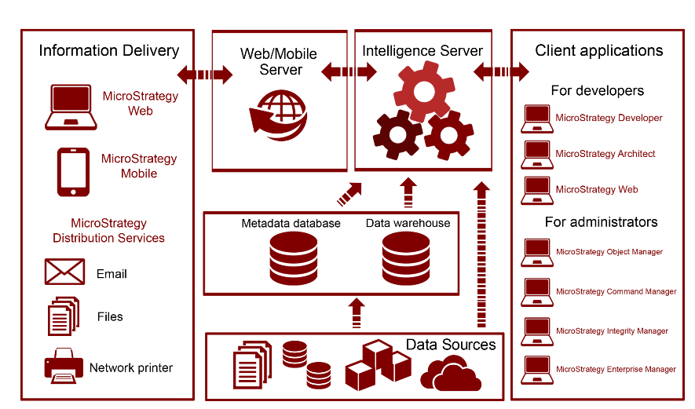

Microstrategy's architecture

At MicroStrategy's platform core resides the Intelligence Server, which connects to a data layer.

This data layer acts as a data source, and it could be a relational database with enterprise data, such as a data warehouse or a specialized data mart. However, the Intelligence Server can also connect to a nonrelational data source such as transactional applications (OLTP), flat files, cube data structures, and website content, to name a few.   
  
There is also a metadata database or repository that the Intelligence Server uses to store the definitions of all MicroStrategy objects.

There are three main groups of client applications, or tools, within the MicroStrategy suite.

* First, there are client applications, which allow developers to create reporting and analytics solutions. These applications are
  + MicroStrategy Developer,
  + MicroStrategy Architect and
  + MicroStrategy Web.
* Next, the information is delivered to the final user or analyst via
  + MicroStrategy Mobile,
  + MicroStrategy Web,
  + Email, Printer, or
  + File (using MicroStrategy Distribution Services, Narrowcast Server, or MicroStrategy Office).
* Finally, there are some applications with the purpose of managing and monitoring the business intelligence projects. Some examples are
  + MicroStrategy Object Manager,
  + MicroStrategy Command Manager,
  + MicroStrategy Enterprise Manager, and
  + MicroStrategy Integrity Manager.

*Narrowcast Server is an information delivery application that is being replaced by Distribution Services.*

In the following sections, you will learn in detail how each component fits into the whole architecture, resulting in a robust business intelligence and analytics platform.

# Main server components

There are two main server groups in the MicroStrategy architecture.  
The core of the MicroStrategy platform is an application server called Intelligence Server.   
There are also two servers that will publish the information to the appropriate delivery method. These servers are the Web and Mobile servers. In the following sections we will learn about them.

**The MicroStrategy Intelligence Server**

The following diagram shows where the Intelligence Server resides within the platform's architecture:

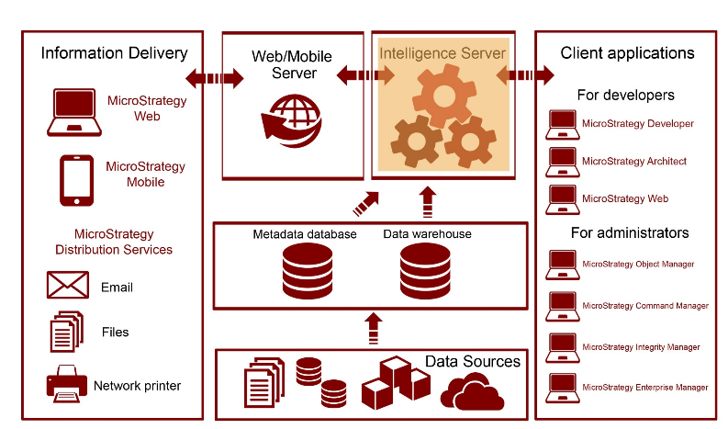

The application server responsible for orchestrating every other component in the MicroStrategy platform is the Intelligence Server, also called I-Server. It is also the component that handles communication with the data sources (such as data warehouse or nonrelational databases) and the metadata database. There are three main I-Server engines, shown as follows:

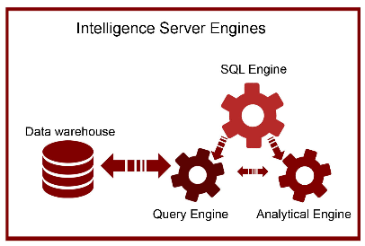

* **SQL Engine**The SQL Engine is responsible for creating the optimized SQL for the database. Once the SQL is generated, the I-Server SQL Engine will pass it to the Query Engine for execution. The SQL Engine also controls the other two engines.
* **Query Engine**The Query Engine is responsible for sending the SQL towards the database. The I-Server Query Engine will connect to the database via ODBC (Open Database Connectivity) and execute the query. Once the SQL is executed, it will receive it and send it to the Analytical Engine for cross tabbing or additional nonSQL functions.
* **Analytical Engine**The Analytical Engine is responsible for nonSQL actions such as in-memory manipulations and cross tabbing. Some typical examples of calculations not resolved by the SQL are functions that are not commonly supported by the database like rankings, subtotals, and other OLAP functions. This engine is also responsible for laying out the data in a cross-tab format.   
  Finally, the Analytical Engine is in charge of any in-memory manipulation of the report (this is after the dataset is returned from the database) such as pivoting, Page-by, sorting, and conditional formatting.

In addition, there are three I-Server components that allow scalability, optimization, and distribution of the information:

* **OLAP Services**MicroStrategy OLAP Services enable MOLAP capabilities with the creation and manipulation of in-memory datasets called Intelligent Cubes. (For more information refer to [Chapter 4](https://learning.oreilly.com/library/view/microstrategy-quick-start/9781789136241/a9f0f9b0-f8bf-4689-aef9-e0f8d002b291.xhtml), *Advanced Reporting - Interacting with and Improving Your Reports*).
* **Report Services**MicroStrategy Report Services allow flexible reporting layouts to create dashboards and scorecards. (For more information refer to [Chapter 5](https://learning.oreilly.com/library/view/microstrategy-quick-start/9781789136241/649fcb73-c184-421f-8c88-cfd90e5f4090.xhtml), *Dashboarding - Creating Visual Reporting*).
* **Distribution Services**MicroStrategy Distribution Services facilitate the delivery of reports and dashboards supporting multiple formats, schedules, and transmitters such as email, printers, and file servers.

# MicroStrategy Web and Mobile servers

The following diagram shows where Web and Mobile servers reside within the platform's architecture:

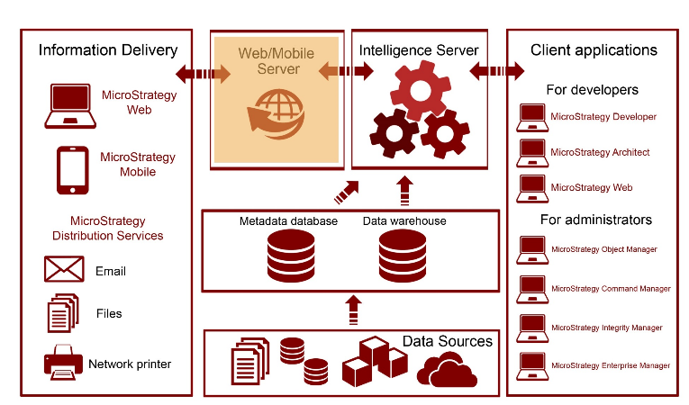

Apart from the Intelligence Server, there are other two server components that connect to the information delivery face of the architecture. These servers are MicroStrategy Web and Mobile. The software components of MicroStrategy Web and Mobile are deployed and published using a web server such as Tomcat or IIS.   
These two communicate with the MicroStrategy Intelligence Server in order to deliver information to the corresponding Web and Mobile client counterparts.

# Client applications

The MicroStrategy platform provides a complete set of client tools and applications that enable developers to build and design BI and analytics solutions, administrators to manage BI projects and their life cycle, and users to interact with data, and to discover and analyze it correspondingly.

All these client applications connect to the Intelligence Server, which manages them and controls how, when, and where the data and information should be directed.

**For developers**

The following diagram shows where developer tools reside within the platform's architecture:

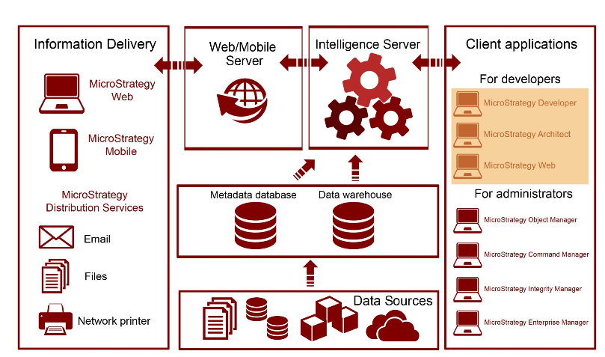

The first client tools are the ones used for design and developing. The applications are MicroStrategy Developer, MicroStrategy Architect, and MicroStrategy Web:

* **MicroStrategy Developer**Formerly known as MicroStrategy Desktop, MicroStrategy Developer is an application that gives developers the ability to create reporting and analytics solutions. This is the tool that power users or advanced developers utilize to build Public Objects, which include Reports, Metrics, Filters, and dashboards.   
  MicroStrategy Developer also contains administrative features to configure, monitor, and secure the BI project.
* **MicroStrategy Architect**MicroStrategy Architect is embedded into MicroStrategy Developer's interface and enables designers and developers to create objects that map to the database structures. These objects are called schema objects. (For more information refer to [Chapter 2](https://learning.oreilly.com/library/view/microstrategy-quick-start/9781789136241/fd4af412-abaf-48a5-b2d6-35619439116e.xhtml), *Project Design - Creating Your Project Foundation*).
* **MicroStrategy Web**MicroStrategy Web is a light client application that permits both developing and performing interactive analysis. It provides a wide range of options, from data browsing, report manipulation and dashboard creation, to self-service, information distribution, and data discovery. In some, this client is used by both developers and final users as well.

**For administrators**

The following diagram shows where administrator tools reside within the platform's architecture:

The second set of client components includes those used for administration, script automation, monitoring, and managing the BI life cycle. Some applications are MicroStrategy Object Manager, MicroStrategy Command Manager, MicroStrategy Enterprise Manager and MicroStrategy Integrity Manager:

* **MicroStrategy Object Manager**MicroStrategy Object Manager allows administrators to copy or promote objects across different environments such as nonproduction, test, and production.
* **MicroStrategy Command Manager**MicroStrategy Command Manager gives the administrators the ability to create scripts to automate the most common administrative tasks. Third-party applications such as BMC Control-M and Airflow, can be integrated with MicroStrategy using Command Manager.
* **MicroStrategy Enterprise Manager**MicroStrategy Enterprise Manager enables analysis of the information generated by the Intelligence Server and the project's usage. It provides a set of Reports and Dashboards that allow administrators to monitor system and report usage, as well as statistics that can be leveraged to create strategies to optimize the BI and analytics environment.
* **MicroStrategy Integrity Manager**MicroStrategy Integrity Manager gives developers a tool to compare environments and the objects within, identifying and highlighting changes or differences that could occur between development, test, and/or production environments.

**For users and analysts**

The following diagram shows where information delivery tools reside within the platform's architecture:

The third set of client applications includes the ones that deliver the information to the final users and analysts. These clients are MicroStrategy Web, MicroStrategy Mobile, and MicroStrategy Distribution Services:

* **MicroStrategy Web**MicroStrategy Web not only serves as software for development but also as a web-based client that delivers rich visualizations, powerful report manipulations, and interactive dashboards. MicroStrategy Web is integrated with MicroStrategy Distribution Services to deliver information in a variety of formats and media, such as email, files, or printed material.
* **MicroStrategy Mobile**MicroStrategy Mobile delivers reports and dashboards anytime and anywhere to tablets and phones such as iPads, iPhones, and Android phones and tablets. MicroStrategy Mobile is fully integrated with the MicroStrategy platform, which allows it to use its report manipulation and visualization features, its flexibility, and at the same time provide security and scalability.
* **MicroStrategy Distribution Services**MicroStrategy Distribution Services is the component of MicroStrategy Intelligence Server that performs the delivery of reports and dashboards in a full range of methods or locations (email, files, MicroStrategy history lists, or network printers) and formats (Excel, PDF, HTML, CSV, text, and so on).

# Installation and configuration

The information conveyed in this section provides the prerequisites and minimum system requirements to install the current MicroStrategy, version 10.X. For prior versions, similar prerequisites apply. To make sure the requirements are met, check the MicroStrategy Release Notes (Readme file) that are included with the packaged installation files. In addition, MicroStrategy Online Community (<https://community.microstrategy.com/s/>) is a great place to find documentation, forums and the latest information about MicroStrategy.

**Prerequisites**

Before installing the MicroStrategy suite you must make sure these prerequisites are covered:

* MicroStrategy installation files: Typically downloaded from the MicroStrategy download site in a compressed file.
* License Key: Obtained from MicroStrategy account executive. MicroStrategy can also be downloaded and installed on a 30-day free trial.
* Administrative privileges: On a Windows installation it is necessary to have a domain account with administrative privileges and access is required. For Unix/Linux, root access is necessary.

Required software:

* For Windows:
  + Microsoft .NET Framework 4.0 or 4.5
  + Web server (to support MicroStrategy Web on ASP.NET) Microsoft Internet Information Services 7.x-8.x
* For Linux/Unix:
  + Web server (to support MicroStrategy Web on J2EE) such as Oracle WebLogic 12c or 10.3.x, IBM WebSphere 7.x-8.0.X, or Apache Tomcat 6.0.x-7.0.X

**System requirements**

The following table serves as a guideline for the MicroStrategy 10 platform installation. These include recommended memory, available storage, and processor for each component.

|  |  |  |  |
| --- | --- | --- | --- |
| **MicroStrategy component** | **Minimum memory** | **Storage** | **Hardware** |
| MicroStrategy Intelligence Server | 4 GB | 12 GB (as a rule, memory times 3) | Windows: 64-bit |
| MicroStrategy Web (Server) | 4 GB | 0.5 GB | Windows: 64-bit |
| MicroStrategy Mobile  (Server) | 4 GB | 0.5 GB | Windows: 64-bit |
| MicroStrategy Developer (including Architect) | 2 GB | 0.25 GB | Windows: 64-bit or 32-bit |
| MicroStrategy Object Manager | 1 GB | 0.25 GB | Windows: 64-bit or 32-bit |
| MicroStrategy Command Manager | 2 GB | 0.25 GB | Windows: 64-bit or 32-bit |
| MicroStrategy Enterprise Manager | 1 GB | 0.25 GB | Windows: 64-bit |
| MicroStrategy Integrity Manager | 2 GB | 0.25 GB | Windows: 64-bit |

Notes:

For Linux/Unix the recommended hardware is:

* Oracle SPARC
* IBM AIX Power Architecture
* HP-UX Intel Itanium
* Red Hat/SUSE Linux 32- and 64-bit

For a complete list of supported and certified configurations, you can google MicroStrategy certified and supported configurations. With every release, MicroStrategy Inc. publishes detailed information about system requirements and supported configurations. The current one can be found at: <https://www2.microstrategy.com/producthelp/10.10/Readme/content/certified_configurations.htm>.

**Windows installation**

To install MicroStrategy on a Windows machine, it is necessary to log in to the workstation or server using an account with administrative privileges. In addition, the database servers must be in reach (via ODBC/JDBC) from the Intelligent Server to guarantee connectivity to the data warehouse (or data marts) and metadata database.

*For development and production installations it is strongly recommended to install the Web/Mobile component on a separate machine from the Intelligent Server. Same goes for other client tools such as Enterprise Manager, Object Manager, Command Manager and Integrity Manager, it is recommended to have them installed on a separate machine too.*

The installation of MicroStrategy is simple and guided by the installation wizard:

1. Download the MicroStrategy suite.
   * For licensed customers go to the MicroStrategy download site: [http://download.microstrategy.com](http://download.microstrategy.com/).
   * There is also a free 30-day trial available at: <https://www.microstrategy.com/us/get-started/enterprise-evaluation>.
2. Locate and execute the setup file (MICROSTRATEGY.exe), shown as follows:

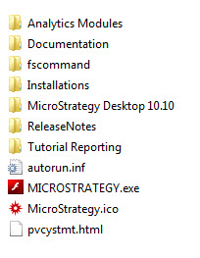

1. This action will launch the installation wizard.
2. Review and accept the license agreement and input the License Key, shown as follows:

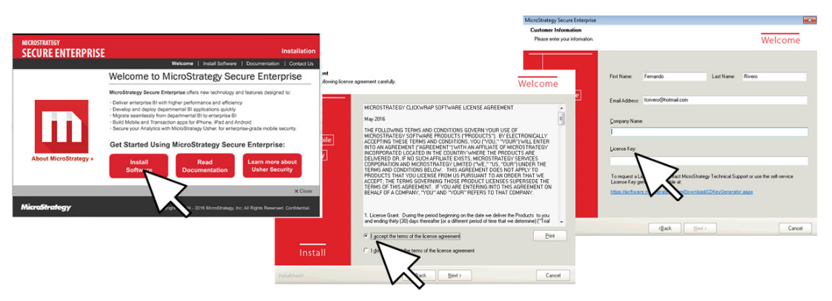

Licences agreement and Licences Key

1. Install options, including destination location and how many products in the suite will be installed, as shown in the next screenshot:

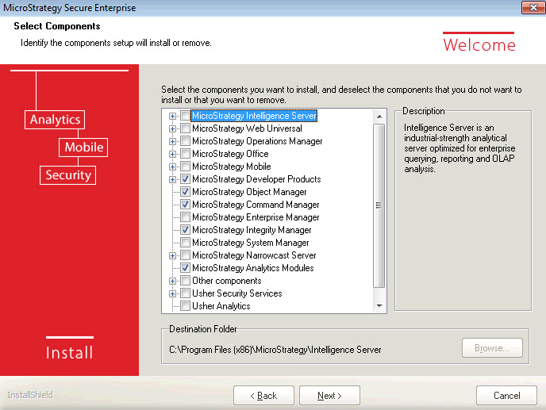

Lists of the products in the suite that will be installed

1. If MicroStrategy Web is selected, it is necessary to establish the **Internet Information Services** (**IIS**) virtual directory in which the MicroStrategy Web code (ASP.NET) will be deployed. Similarly, for MicroStrategy Mobile, a new virtual directory for the IIS will be created.
2. Continue with the summary of products to be installed and start the process.
3. When the installation wizard completes, restart the computer to make sure the installation process has completed successfully.

# Unix/Linux installation

There are different installation methods for MicroStrategy on Unix/Linux, either using a **Graphical User Interface** (**GUI**), in command-line mode, or silent mode (automated). The GUI mode and the command-line mode will launch the MicroStrategy Installation Wizard displaying the same pages and requesting the same information as the Windows counterpart. It is important to note, though, that MicroStrategy Object Manager , MicroStrategy Developer and MicroStrategy Enterprise Manager can't be installed in a Unix/Linux box.

# The MicroStrategy metadata

By definition, a metadata is "data about the data." It is usually a file or database that describes another set of data or information. In MicroStrategy, the metadata repository is a database that contains the definitions of database objects such as tables and fields in a way that developers and users can easily understand. The MicroStrategy metadata could be thought of as a logical bridge between the technicalities of the database and the business terms, measures, and contexts of the organization.

The MicroStrategy metadata maps logical abstractions, called objects, to physical database objects, as illustrated in the following diagram:

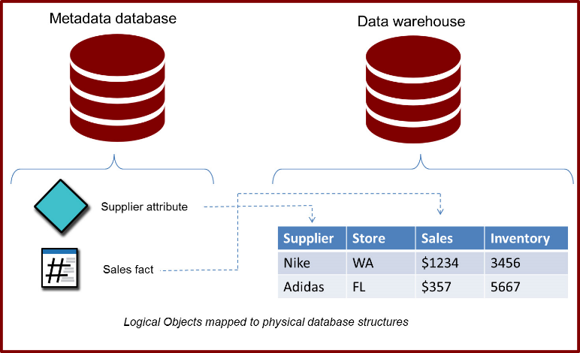

**Creating and configuring MicroStrategy metadata**

Before creating the MicroStrategy metadata, it is necessary to have the following two prerequisites ready:

* A blank database (Amazon Redshift, DB2, Informix, Impala, SQL Server, Oracle, and so on. For a complete list of certified MicroStrategy metadata databases, check the Readme file or release notes corresponding to the version you are installing.)
* A DSN (Data Source Name) using the corresponding ODBC/JDBC driver to that blank database.

*MicroStrategy Connectivity Wizard can also be used to create a DSN.*

The steps to create the MicroStrategy metadata are:

1. Open the MicroStrategy Configuration Wizard (macfgwizw.EXE). This tool will let you create a MicroStrategy metadata, configure an Intelligence Server, and create a project source among other configuration tasks, as shown in the following screenshots:

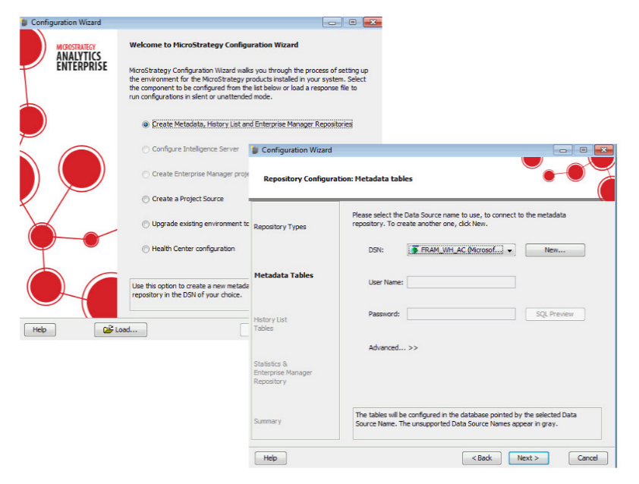

1. Select the corresponding option for metadata creation: | Create Metadata, History List and Enterprise Manager Repositories.
2. Select a DSN. The DSN will have the connectivity information and driver to access the blank database using ODBC/JDBC protocol.
3. Follow the review window and click Next until the metadata table creation starts.
4. During the creation of the MicroStrategy metadata, the MicroStrategy Configuration Wizard creates an empty shell with table structures that will host data about the data. The data that will be later populated within the structures is what we will refer to as MicroStrategy objects. This concept will be explained in the next chapter.

**Intelligence Server configuration**

Once the Intelligence Server is installed, it needs to be pointed to a MicroStrategy metadata. Once again the Configuration Wizard is used to perform this task. The object resulting from configuring an Intelligence Server is called a Server Definition. In order to create one, it is necessary to take into consideration the following prerequisites:

* The Configuration Wizard must be executed directly from the same machine where the Intelligence Server is running
* A DSN pointed to the MicroStrategy metadata database must be created in the same machine where the Intelligence Server is running

The steps to configure an Intelligence Server, pointing it to a MicroStrategy metadata are:

1. Launch the MicroStrategy Configuration Wizard (if you proceed from the above procedure, the MicroStrategy metadata creation, this wizard should be already open for you).
2. Select the corresponding option for the Intelligence Server configuration: | Configure Intelligence Server.
3. Select a DSN. This DSN must point to the metadata.
4. Once the DSN information is entered, it is necessary to either create or select an existing Server Definition.
5. The configuration process begins with the Intelligence Server being stopped, then it is pointed to the specified metadata and automatically started again, completing the Server Definition creation or switching to a different one.

**Project sources (2-tier and 3-tier)**

Once the MicroStrategy metadata is built and the Intelligence Server configured, it is necessary to create one or more Project Sources. A Project Source could be defined as a direct or indirect access point to the metadata. It is used by MicroStrategy Developer and other client interfaces to build, interact, and manage the contents of the MicroStrategy metadata.   
A Project Source can be created using the MicroStrategy Configuration Wizard or the Project Source Manager.  
  
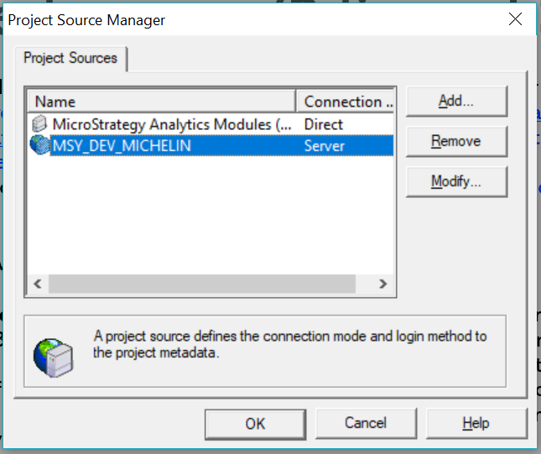

There are two types of Project Sources:

* **2-Tier (Direct)**: It is a Project Source pointed directly to a MicroStrategy metadata using an ODBC/DSN connection. This type of configuration is not recommended for production implementation since it won't guarantee mutual exclusion to the metadata. The 2-Tier configuration, illustrated in the following diagram, is only recommended for some maintenance and administrative tasks that require exclusive access to the metadata while the Intelligence Server is down.

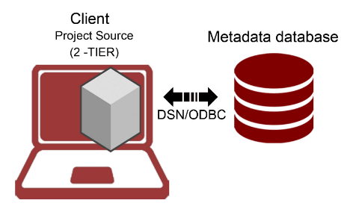

To create a 2-Tier or Direct project source it is necessary to have a DSN/ODBC connection ready pointing to the MicroStrategy metadata database and corresponding credentials. Following are steps to create it from Developer:

1. Tools Menu | Project Source Manager.
2. Provide a Project Source name.
3. Add | select in connection mode Direct.
4. Provide ODBC DSN with corresponding login and password.

The following screenshot shows what your Project Source Manager will look like:

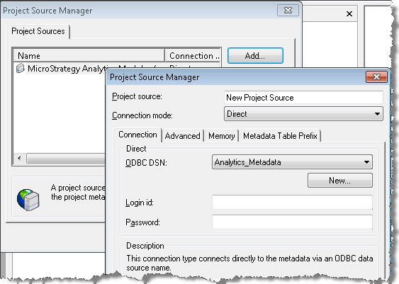

* **3-Tier (server)**: This is a Project Source pointed to the MicroStrategy Intelligence Server that in turns points to the MicroStrategy metadata. This is the configuration used for development and production. A 3-Tier configuration will guarantee that the access to the MicroStrategy metadata is controlled by the Intelligence Server providing centralization, security and fail over support (when combined with a cluster of servers). The below diagram depicts a 3-tier configuration:

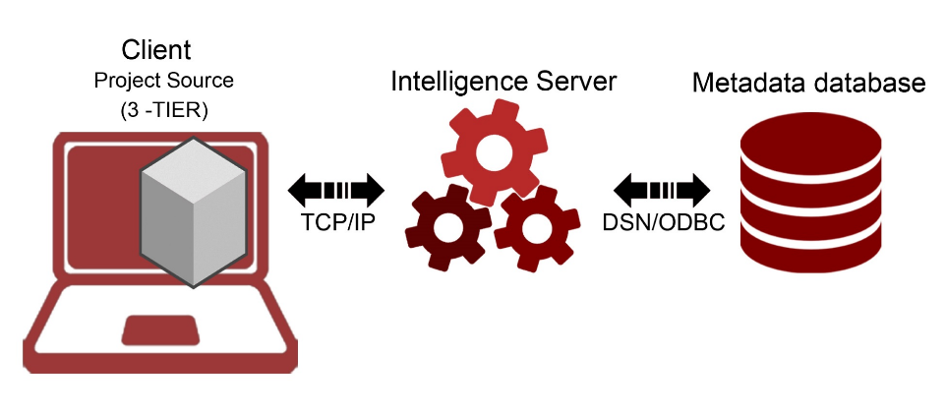

To create a 3-Tier or server Project Source, it is necessary to have the Intelligence Server IP address or server name. Follow these steps to create it from MicroStrategy Developer:

1. Go to Tools Menu | Project Source Manager.
2. Provide a Project Source name.
3. Add | select in connection mode Server.
4. Provide the Intelligence Server IP address, or server name, and a port number if applicable.

# 4-Tier configuration (MicroStrategy Web and/or Mobile)

Once the Intelligence Server is configured and pointed to a MicroStrategy metadata, the MicroStrategy Web and/or Mobile Server should be configured as well. Open the Web Administrator page, it is usually found in this URL if installed on Internet Information Services (IIS) Web Server https://<your server name>/asp/Admin.aspx . Then add the Intelligence Server IP address or domain name to connect via TCP/IP. The following diagram depicts this type of arrangement, which is called 4-Tier configuration:

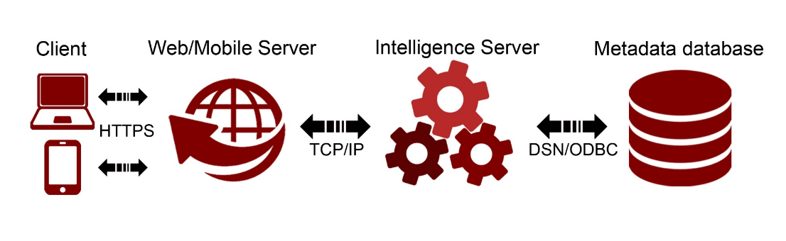

# Summary

At this point, you should be familiar with the MicroStrategy Platform architecture and understand how the different components relate to each other. Also, you should be able to install MicroStrategy and perform basic configurations such as metadata database creation, Intelligence Server configuration, and Project Source creation (in 2 and 3-Tiers).

The next chapter will introduce the important concept of MicroStrategy Objects. We will learn about a specific category, which will be the foundation for any MicroStrategy Project: The Schema Objects.

# Project Design - Creating Your Project Foundation

Technically speaking, MicroStrategy's core task is to translate business questions into the language that databases speak: SQL. In other words, MicroStrategy offers a logical bridge between business users and the data. This bridge is possible because of MicroStrategy's Objects, which in turn reside in its metadata database.

This chapter will establish the base for designing and building a MicroStrategy project. It will first define and explain the concept of MicroStrategy Objects and then describe the main object categories. Then the main Schema Objects, such as Attributes and Facts, will be covered. The following topics will be the focus of this chapter:

* What is a MicroStrategy Object?
* Which are the main object categories?
* Understanding a MicroStrategy Project and how to create one
* Understanding a MicroStrategy Schema Object
* Explaining MicroStrategy Attributes and how to create one
* Explaining MicroStrategy Facts and how to create one
* Explaining MicroStrategy Hierarchies and how to create one
* Explaining MicroStrategy Transformations and how to create one

**MicroStrategy Objects**

MicroStrategy Objects are logical abstractions of mainly database components, such as tables and columns. However, there are some objects that represent other things such as databases (connections), users, server nodes, schedules, and devices, to mention a few. All MicroStrategy Objects are stored in the MicroStrategy metadata database. In other words, if it is stored in the metadata then it must be a MicroStrategy Object.

This wide variety of MicroStrategy Objects are grouped into the following three main categories:

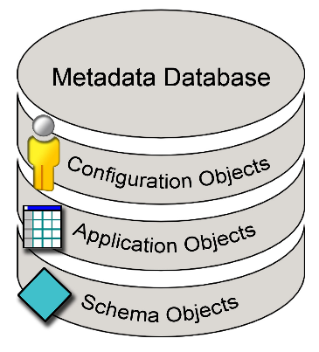

Three categories of Microstrategy

* **Schema Objects**: These objects directly represent database objects such as columns, tables, and partitions. Some examples are: Tables, Attributes, Facts, Hierarchies, and Transformations.
* **Application Objects**: Also known as Public Objects, these objects represent reporting and visualization objects. Some examples are: Reports, Templates, Metrics, Filters, Prompts, and Documents.
* **Configuration Objects**: These objects represent administration, security, and Configuration Objects. Some examples are: Users, Groups, Database Connections, and Schedules.

**Framework to learn about MicroStrategy Objects**

Some years ago, when I used to teach MicroStrategy, I utilized a very effective framework to learn about the multiple and diverse MicroStrategy Objects. This framework consists of three simple questions:

|  |  |
| --- | --- |
| 1. What is it for? | Describe the purpose of the MicroStrategy Object. |
| 1. What is it made of? | List what other MicroStrategy Objects reside within (its components) or what it represents. |
| 1. Where can it be used? | Explain in which other MicroStrategy Objects it could be embedded (its dependents). |

I will use this same framework for each MicroStrategy Object covered in this book.

# MicroStrategy Analytics Modules

When MicroStrategy is installed, there is the option to install MicroStrategy Analytics Modules. Basically, this option will install two sample projects: MicroStrategy Tutorial and Human Resources Analysis Module. These two projects are installed and configured automatically. Both the data warehouse and the metadata databases reside on Microsoft Access. In addition, a 2-Tier Project Source is also created and accessible from MicroStrategy Developer. The login is Administrator with a blank password.

It is recommended to leave these sample projects to perform testing of MicroStrategy Features and self-training in a DEV or System Test environments, never in Production. Otherwise, these could be uninstalled. Throughout this book, we will use these two projects to describe examples and perform exercises.

# MicroStrategy Developer

MicroStrategy Developer is a client interface that was conceived while thinking of an interface that the majority of the developers and users are familiar with: Windows Explorer. Microsoft Windows Explorer is a tool that helps the user to visualize, manage, organize, create, and delete files in a PC. Similarly, MicroStrategy Developer (which by the way was called MicroStrategy Desktop for many years before version 9.5) is a tool that helps the user to visualize, manage, organize, create, and delete MicroStrategy Objects in the metadata.

Although other MicroStrategy clients, covered in [Chapter 1](https://learning.oreilly.com/library/view/microstrategy-quick-start/9781789136241/19f2500c-9b42-40c7-afcb-a1a6924db287.xhtml), Architecture – Installing and Configuring MicroStrategy, will offer some specific functionality and interaction with the MicroStrategy Objects, MicroStrategy Developer is the main client to develop and manage all three object categories, as shown in the following screenshot:

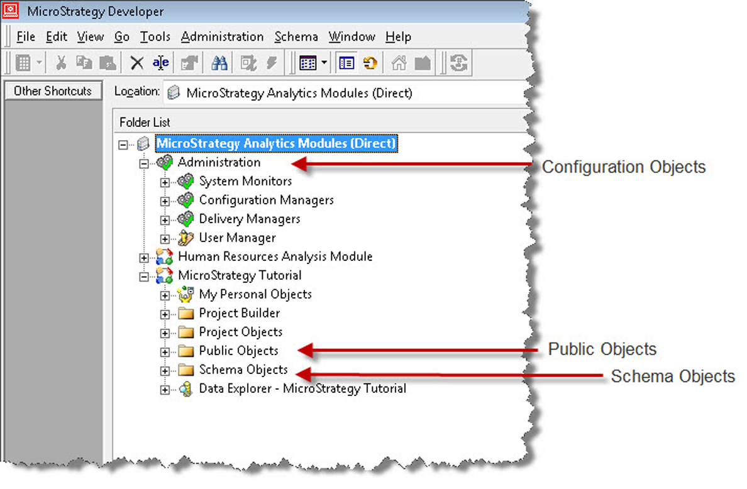

Using MicroStrategy Developer to manage all three categories

Notice that the MicroStrategy Developer tree structure is similar to that of Windows Explorer. Similarly, actions such as drag and drop, copy and paste, renaming (F2), and folder creation, to name a few, follow the same paradigm as in Windows, making MicroStrategy Developer very familiar and intuitive to the developer and user.

Although there are some folders already created by default by MicroStrategy, developers can create as many as they want, rename them, and move Schema and Public Objects arbitrarily within these. However, it is recommended to keep these objects separated for ease of administration and maintenance. Conversely, the configuration objects only reside within the section named Administration.

# MicroStrategy Projects

MicroStrategy Projects are Configuration Objects, which group all other objects within (Public and Schema).The following is a quick reference table for this MicroStrategy Object:

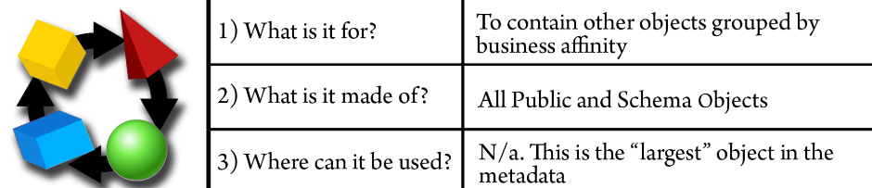

The Projects are usually created according to a business area (such as marketing, finance, and human resources) or, in some organizations, by the technology that supports its data source (such as Teradata, Oracle, SQL Server). In any case, a MicroStrategy Project helps developers and users to organize their reporting and analytics applications. There are other Configuration Objects, but these will be covered in [Chapter 6](https://learning.oreilly.com/library/view/microstrategy-quick-start/9781789136241/fc2effe1-1dd1-406c-94d4-4bc6d06b96ae.xhtml), Security – Managing Your Users and Their Access and [Chapter 7](https://learning.oreilly.com/library/view/microstrategy-quick-start/9781789136241/aac45770-f3d9-4af3-913d-55f7105d3290.xhtml), Administration – Maintaining and Monitoring Your Project.

**Project structure**

When a MicroStrategy Project is created, a general folder structure common to every project is generated:

* **My Personal Objects:** This set of folders is meant to save objects that are not shared among other users. Meaning, whatever is saved within it remains private to the logged-in user (and the MicroStrategy Administrator).
* **Project Builder**: Project Builder is a wizard to create quick projects and proof of concepts. This folder within the project structure will hold the created objects resulting from the process.
* **Project Objects**: This folder holds some specific Application / Public Objects such as Security Filters and Subtotals.
* **Public Objects**: This folder stores the remaining Application Objects generally available to users and is shared among them.
* **Schema Objects**: This folder contains Schema Objects created by the project Architect.
* **Data explorer**: This is a data visualization tree that will show the Project's Attributes and their relationship along with the elements (data) stored in the dimension or lookup tables.

This structure provides a guide for developers to store the different objects and publish them for final users. It is also best practice to use this default folder structure. However, they are free to rename and move the objects to whichever location they want.

There are only a few locations that are mandatory for some specific actions and/or functionality. These locations are:

* **Public Objects / Reports**: This location is mapped to MicroStrategy Web as a Shared Reports folder. The objects and subfolders within are visible through the Web Client interface.
* **Schema Objects / Hierarchies / Data Explorer**: This folder contains Hierarchies that the developer wants to make available through the Data Explorer visualization tree. We will learn about Hierarchies later in this chapter.

**Exercise – create your first Project**

In this exercise, you will use the MicroStrategy Project Creation Assistant to create and configure your first Project:

1. Log into the MicroStrategy Analytics Modules (Direct) Project Source. Use as credentials Administrator/no password.
2. Go to the Menu Schema | Create New Project.
3. The Project Creation Assistant will open. Select Create project and add the MicroStrategy Essentials name and a description (optional). Then click OK, as shown in the following screenshot:

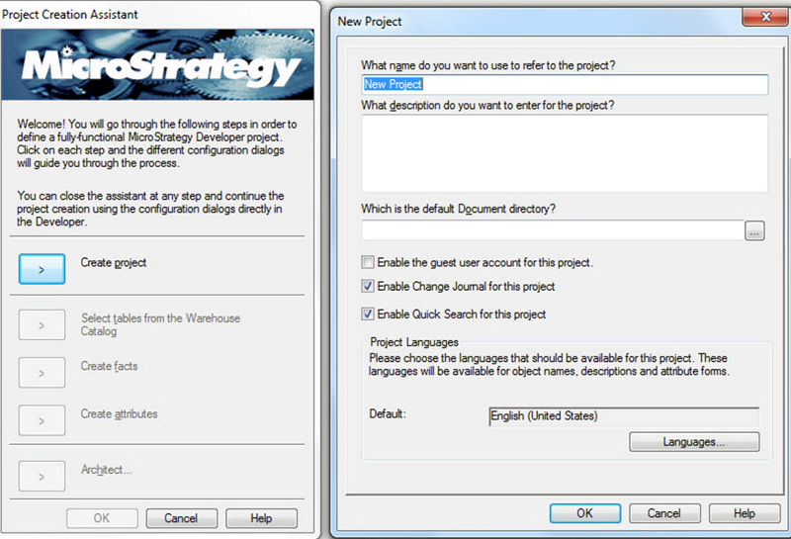

Project Creation Assistant

1. The Project is created and the user can continue using the wizard, or exit by clicking OK and follow the project configuration and objects creation manually.
2. For this exercise, we will do an additional step that will help to associate a database (data warehouse) to our newly created project. Click on “Select tables from the Warehouse Catalog” This action will prompt the selection of a Database Instance, shown as follows:

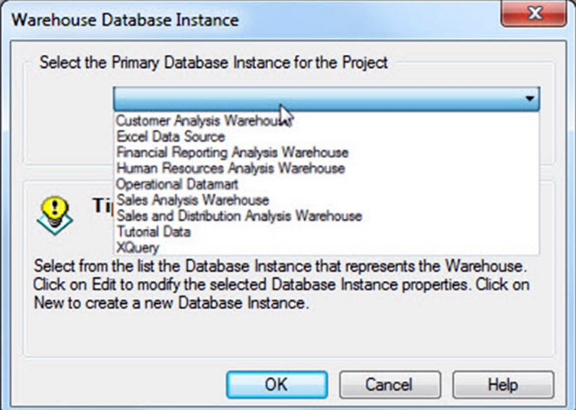

Associating a database to our newly created project

1. Select Tutorial Data. A MicroStrategy Database Instance is a configuration object used to connect to a database. We will learn later in [Chapter 7](https://cdp.packtpub.com/microstrategy_essentials/wp-admin/post.php?post=25&action=edit#post_30), *Administration – Maintaining and Monitoring Your Project*, how to create them and configure a MicroStrategy Project, pointing it to a data warehouse or data mart. For the sake of this exercise, we will use a previously created Database Instance pointing to a retailer called Tutorial. If you want to see the Microsoft Access database, it is located within the Tutorial Reporting folder (in Windows C:\Program Files (x86)\MicroStrategy\Tutorial Reporting) with the name TUTORIAL_DATA_7200.mdb.

*Unix/Linux installations don't have this Microsoft Access file.*

1. When you click OK, the Warehouse Catalog is opened. We will later explain what this is. For this exercise, just close the window (red X on right corner). Then again click OK on the Project Creation Assistant. You will see a message telling you that it is possible to continue the Project creation without the assistant. Don't click OK again.
2. This finalizes the exercise. You should now see your new Project within the Project Source along with the MicroStrategy Tutorial and Human Resources Analysis Module Projects.

# Your building blocks – Schema Objects

The MicroStrategy Schema Objects are going to be the foundation of any project. These objects serve as building blocks on which other objects will be erected.   
Generally speaking, Schema Objects are mapped to database structures such as tables or columns with a few exceptions in which other Schema Objects are used as part of their components.   
  
Usually, there is only one person at a time creating or modifying Schema Objects. This person is called the project Architect. It is not recommended to have multiple persons modifying Schema Objects since this could lead to metadata inconsistencies and eventually corruption. Once any change has been performed to a schema object, it is necessary to commit this change into the metadata. To do so the Architect must Update Schema.

**Exercise – updating Schema**

It is very important to update the project's Schema every time there is a Schema Object change, addition, or deletion. In this exercise, you will learn how to update the Schema with the following steps:

1. Select the project where the schema will be updated. For this exercise select the MicroStrategy Tutorial project.
2. Open the project by double clicking on it or clicking on the plus symbol on its left.
3. Go to the Schema menu | Update Schema.
4. On the next window, shown as follows, make sure only the first option is selected with Update schema logical information | Update:

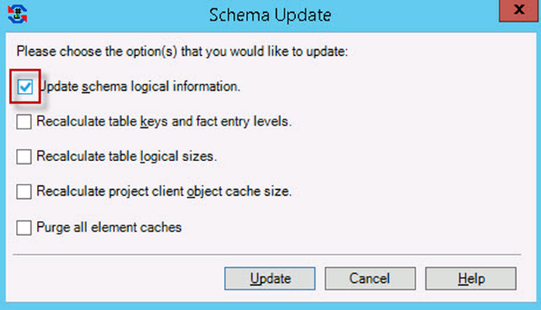

Selecting the Update Schema logical information

The other options are related to other Schema and administrative tasks.

1. This finalizes the exercise.

The schema can be updated at any time, even if no change has been introduced on the Schema Objects (like in the exercise). However, it is mandatory to do so when any schema object has been modified, created, or deleted. Failing to update the schema might result in memory differences with the physical metadata and eventually a metadata corruption.

# The Source – Tables

The first **Schema Object** to be created must be a MicroStrategy Table. The following is a quick reference table for this MicroStrategy Object:

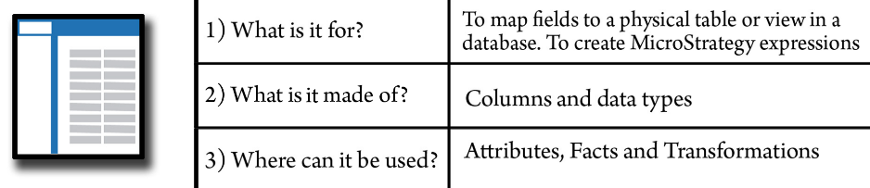

This object is simply the logical representation of a table in the database (data warehouse). MicroStrategy imports into the object definition the table name, structure, columns, and data types. In addition, MicroStrategy assigns a value to the table based on the fields and Attributes mapped to it. It is important to mention that this number doesn't represent a measure of megabytes or number of rows but instead a conceptual value; this is why it is called the **“logical table size”.**   
  
This number is utilized by the MicroStrategy SQL Engine to choose which table should be used for the query when two tables are available to get the same data. MicroStrategy chooses the table with the smaller logical table size to optimize the query. Nevertheless, this number can be manipulated by the project Architect. An example of this scenario would be forcing the MicroStrategy SQL Engine to choose a table with a lower level of detail over a summary table.

# Warehouse Catalog

Tables are created through the MicroStrategy Warehouse Catalog. This window shows on the left pane the physical tables and views available in the warehouse database and on the right pane which of those tables have been created as MicroStrategy Tables. Once a table is moved from left to right, its definition is saved in the MicroStrategy metadata as an object, a logical table, as shown in the following screenshot:

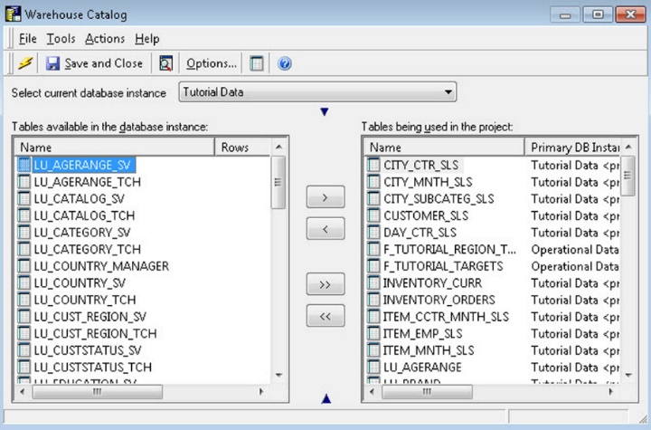

Definition  saved in the MicroStrategy metadata as an object

**Table structure**

Each Table in MicroStrategy has two main views:

* **Logical view**: This view will show which Attributes and Facts are mapped to the table along with information about keys and logical size.
* **Physical view**: This view shows the columns/fields and associated data type from the actual database table, as shown in the next screenshot:

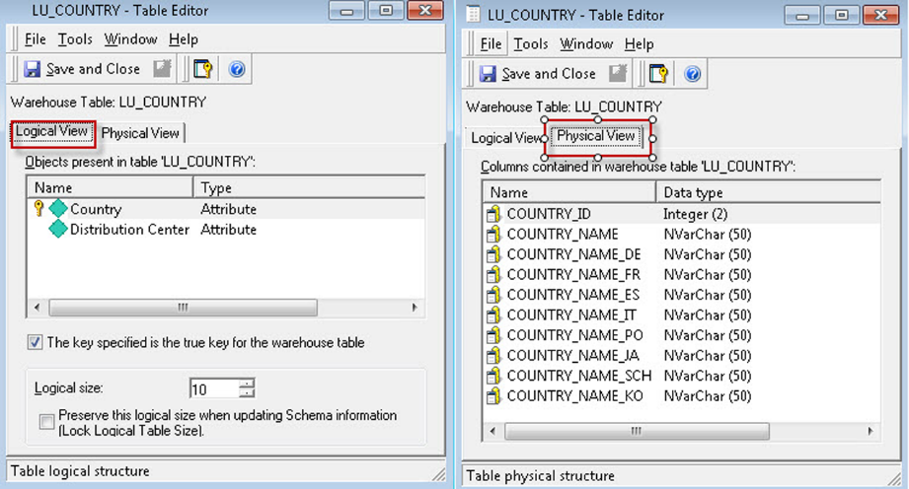

The Logical and Physical view of a table in MicroStrategy

**Exercise – Import a few Tables**

In this exercise you will use the MicroStrategy Warehouse Catalog to import a few Tables.

1. Open your newly created project MicroStrategy Essentials.
2. Access the Warehouse Catalog: Go to menu Schema | Warehouse Catalog.
3. Select current database instance | Tutorial Data. This dropdown will show the connections to different databases in your environment.
4. Select LU_COUNTRY, LU_REGION and LU_CALL_CTR and move them to the right pane, shown as follows:

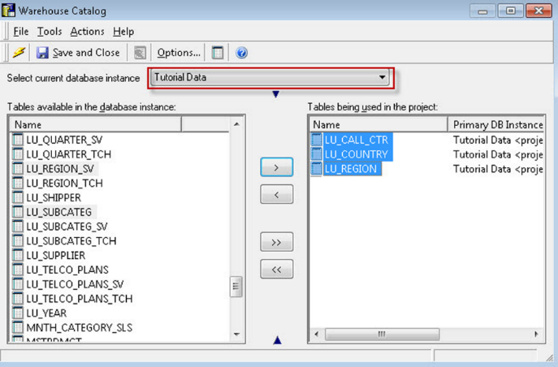

Moving LU_COUNTRY, LU_REGION and LU_CALL_CTR to the right pane

1. Save and Close.
2. Update the Schema.
3. This finalizes the exercise.

**Business raw measures – Facts**

MicroStrategy Facts are objects that represent a business measure stored in a database table. The following is a quick reference table for this MicroStrategy Object:



 These measures usually have the following characteristics:

* They are numerical
* They can be aggregated (summed up or operated in some way)

The Facts usually map directly to one or more columns in a Fact table.  
The Fact is defined with a MicroStrategy expression. An expression could be:

* **Base**: an expression which is represented as a single table field
* **Derived**: an expression in which two or more table fields are operated or a function is applied to them

The Fact on its own is meaningless. It needs a context and a rule of aggregation in order to be useful. In the following sections, we will learn about which other MicroStrategy Objects serve this purpose.

**Exercise – creating Facts**

In this exercise you will learn to create Facts. Take the following steps:

1. Open your newly created MicroStrategy Essentials project then import the Table MNTH_CATEGORY_SLS and update the Schema (hint: use the Warehouse Catalog). You can refer to the previous table exercise if you get stuck.
2. Go to the Facts folder (under Schema Objects) and right-click New | Fact.

The Fact Editor has two windows. The inner one is the Fact Expression editor while the outer one is the Fact Editor, shown as follows:

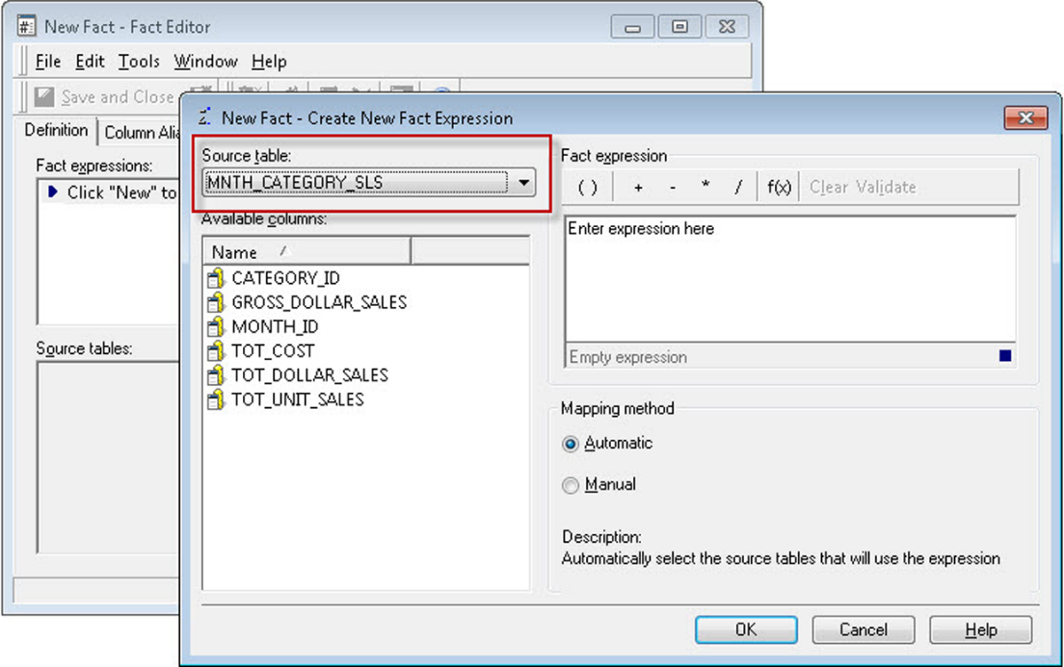

Fact Expression editor ad Fact Editor

1. In the Expression editor, make sure the Source table dropdown shows the MNTH_CATEGORY_SLS table.
2. Double-click on TOT_DOLLAR_SALES | OK. The automatic mapping method will relate this object to any other table in the Project where this specific expression exists.
3. Review your Fact. Check the expression on the upper pane and the related source table(s) on the lower pane, shown as follows:

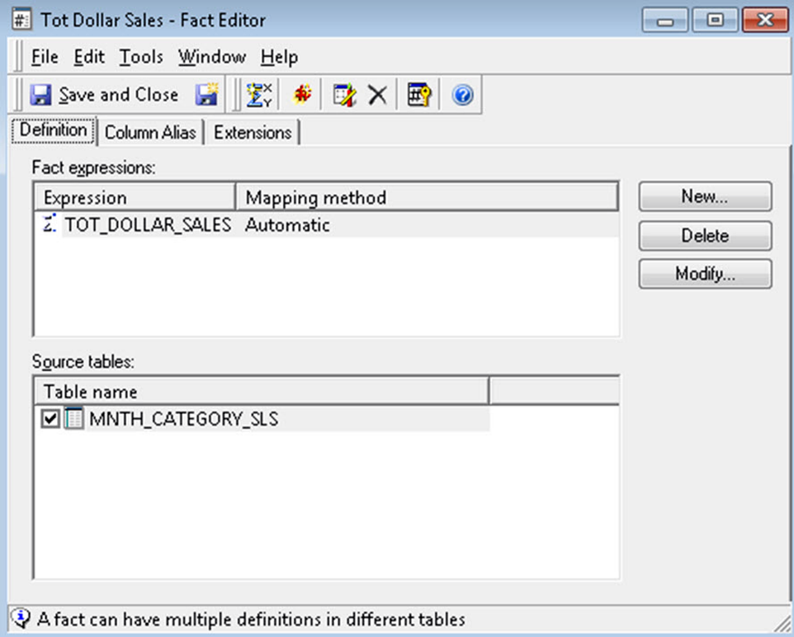

Reviewing your Facts

1. Save and Close on the Fact Editor. Leave the default object name as Tot Dollar Sales.

*You can update the Schema now or wait until you create or modify multiple Schema Objects.*

1. Repeat the above process for the GROSS_DOLLAR_SALES Fact.
2. Update Schema. This finalizes the exercise.

*Note: MicroStrategy Facts can't be used directly on Reports. It is necessary to create an Application Object on top (Metrics) that will describe the aggregation function and aggregation level for the business measure.*

**Business context – Attributes**

MicroStrategy Attributes are objects which represent a business context, or dimension. The following is a quick reference table for this MicroStrategy Object:



 The Attributes will provide the level in which a given Fact is stored in the database and which that Fact can be aggregated to. An Attribute could be mapped to one or more columns in a database table. These tables are commonly referred to as lookup tables or dimension tables. However, it could be mapped to any type of table such as Fact tables.

As opposed to the Facts, the Attributes are not directly built from MicroStrategy but from one or more MicroStrategy **Attribute Forms**. The following diagram helps you to understand how an Attribute is defined in MicroStrategy:

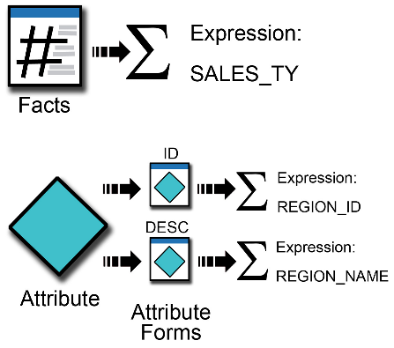

An Attribute form is a characteristic of the same business context. From the previous diagram, we can see that there is an Attribute that has two forms: one is an identification number, and the other is a description. Both columns define the same business context which could be the business region.   
An Attribute must have at least one form (ID) and could have as many other characteristics as required. For example, the customer Attribute could have the following forms:

* ID
* First name
* Last name
* Suffix
* Prefix
* Nickname

# Understanding the Attribute Editor

As opposed to the Fact Editor where there are only two nested windows, the Attribute Editor has three (listed from the inner to the outer window): Form Expression Editor, Attribute Form Editor and Attribute Editor, shown as follows:

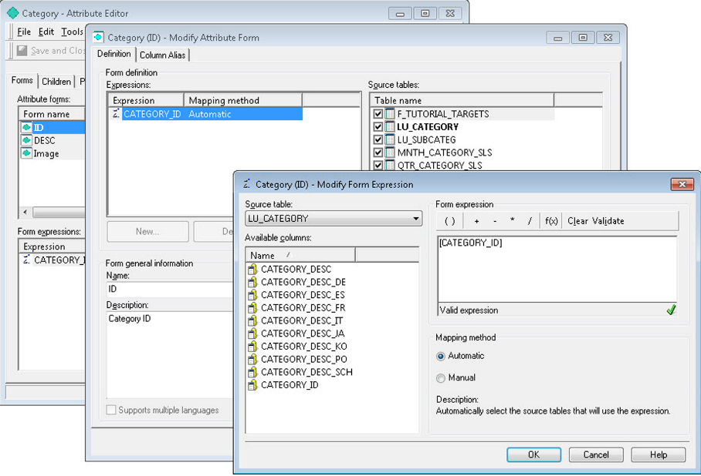

Three windows of the Attribute Editor

The inner most window, the Form Expression Editor, is where you define each Attribute form's expression in a similar way as the Fact's expressions are defined. First, select a MicroStrategy Table as the source. The expression for a certain Attribute form could reside in one or more tables in the database. If you want to manually associate the tables, choose the Manual mapping method, otherwise the Automatic mapping method will relate the Attribute form expression to any other table in the Project where it exists. In the previous image, the CATEGORY_ID expression comes from the LU_CATEGORY table, and it is automatically mapped to any other table where CATEGORY_ID could be found.

Once the form expression is created**, you must select a lookup table**. The lookup table is a table where MicroStrategy will pull the description for a unique set of business contexts IDs. It is usually called data catalog or dimension table. You can control it in the second-inner window (Attribute Form Editor), which is the lookup table, which shows the tables the form is associated with and other form settings such as data type, alias, and default sorting, as shown in the next screenshot:

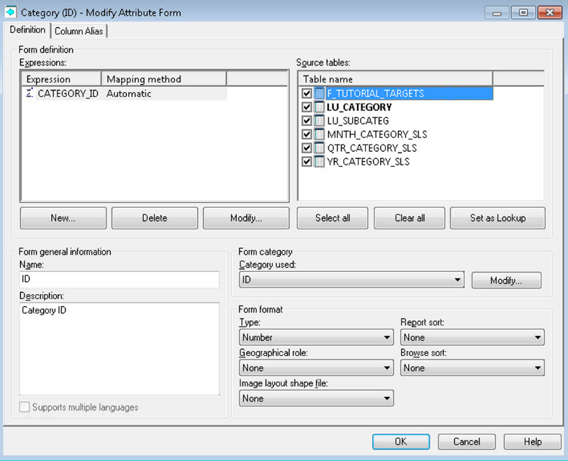

Attribute Form Editor

The next step in the Attribute creation process is to verify the forms created and/or create additional forms. Usually an Attribute has an ID and a DESC (description) form, shown as follows:

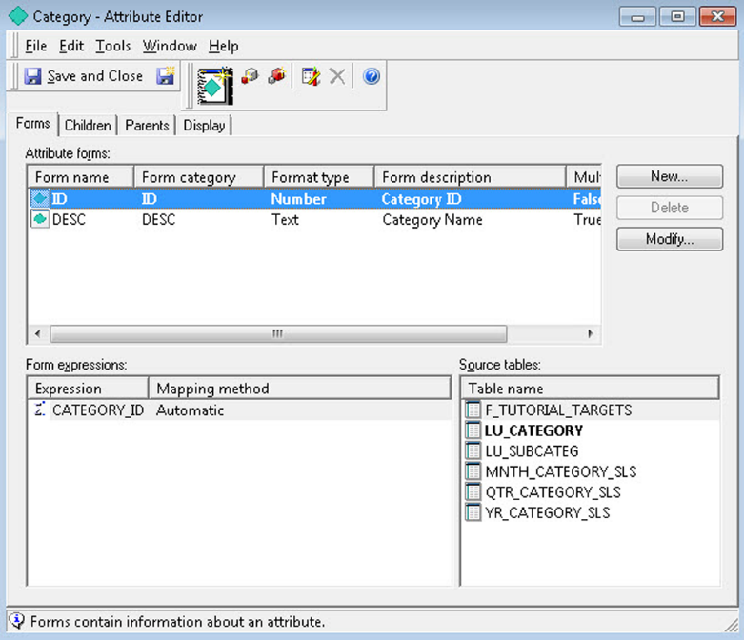

Attribute creation

In the outer most window you will be able to define Attribute Relationships, and see how they relate with other business contexts within the same dimension or Hierarchy. To add a relationship, simply go to the corresponding (children or parents) | Add tab, and establish a relationship type and relationship table, as follows:

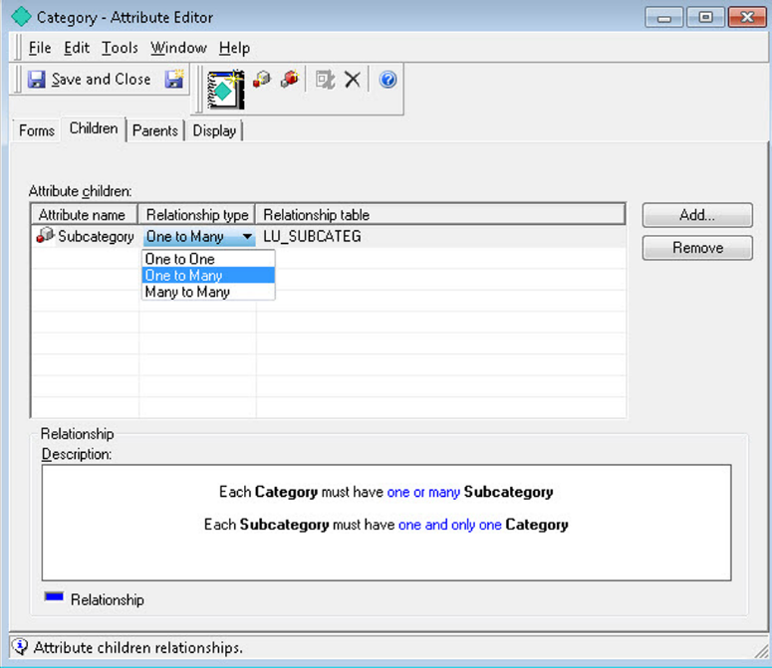

Adding and establishing a relationship type and relationship table

*It is important to make sure the Architect understands the data model and how the different Attributes should be related. If you don't see an Attribute or table candidate related to another, it is likely that the data model doesn't support it.*

**Exercise – creating Attributes**

In this exercise, you will learn to create Attributes. Take the following steps:

1. Open your new MicroStrategy Essentials project and go to the Schema Objects | Attributes folder.
2. Right-click New | Attribute.
3. The Attribute Editor will open the three nested windows. In the innermost, the For Expression must be defined. Select the LU_COUNTRY table.
4. Double-click on the COUNTRY_ID column. Leave Automatic mapping | OK.
5. You should now be on the second window, the Form Editor. Verify that the lookup (in **bold**) table is LU_COUNTRY. Which other table is selected? If you had selected the Manual method, none of the tables would have been selected and you must manually check which should be used.
6. As shown in the following screenshot, verify that the form category is ID and the data type is Number | OK:

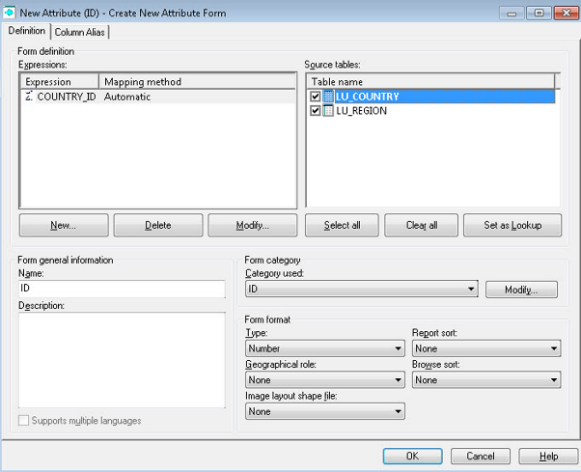

Verifying the form category and data type

1. You should now be on the outermost window. So far only the ID form has been created. You will now add a description for this Attribute. Click on New to add a new Attribute form, shown as follows:

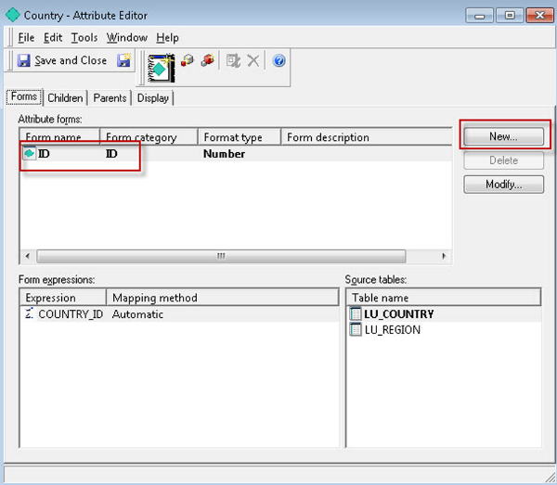

Adding a description for the Attribute

1. Using the same source, the (LU_COUNTRY) table, define an expression for COUNTRY_NAME. Repeat steps 4 to 6, but this time for the text field that will be used as a description for Country. Your Attribute Editor window should show both ID and DESC forms created, shown as follows:

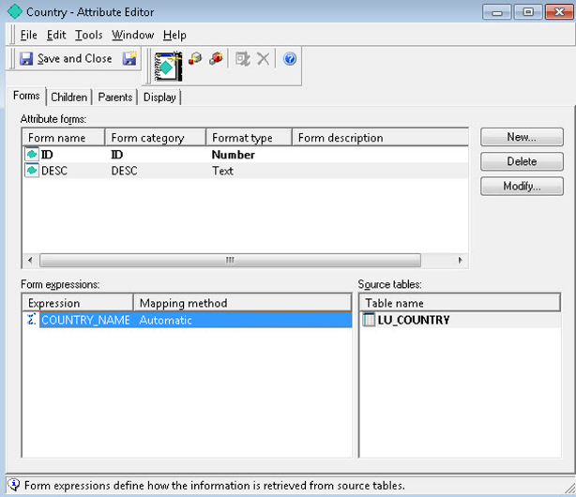

Attribute Editor displaying ID and DESC

1. Save and Close. Leave the default object name as Country | Save.
2. Repeat the process to create a Region Attribute with the following information:
   * **Source table / lookup table**: LU_REGION
   * **Attribute forms**: ID (REGION_ID) and DESC (REGION_NAME)
   * **Parent**: Country

11. To assign the region parent go to the Parents tab | Add | select Country Attribute | OK. The relationship type and table should look like the following:

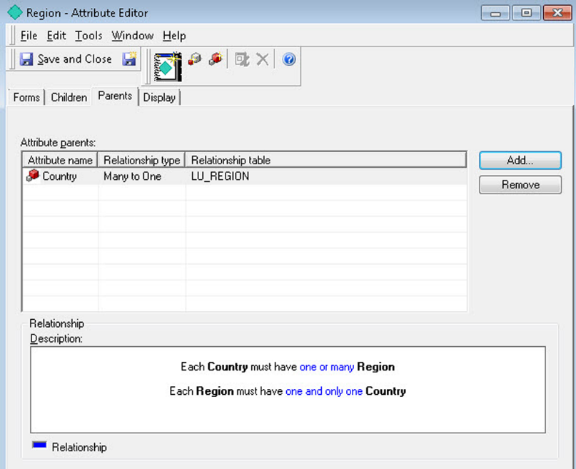

Relationship type and table

1. Save and Close. Leave the default object name as Region | Save.
2. Repeat the process to create a Call Center Attribute with the following information:
   * **Source table / lookup table**: LU_CALL_CTR
   * **Attribute forms**: ID (CALL_CTR_ID) and DESC (CENTER_NAME)
   * **Parent**: Region

14. Save and Close. Leave the default object name as Call Ctr | Save.

1. Update Schema. This finalizes the exercise.

**Grouping business context – Hierarchies**

MicroStrategy Hierarchies are Schema Objects made of Attributes, which serve two main purposes:

* Help to visualize and understand the relationships between the Attributes
* Define paths for users to drill (drill maps and drill paths)

The following is a quick reference table for this MicroStrategy Object:

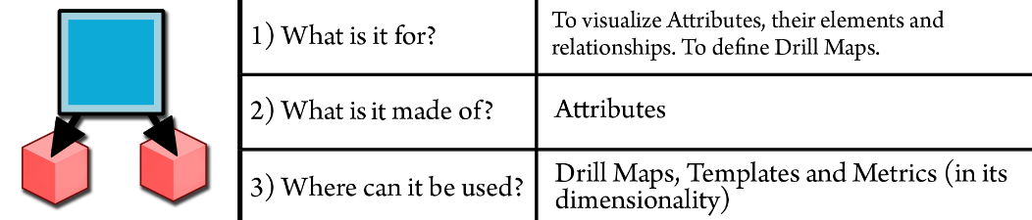

If you navigate to the Data Explorer, you will find the first Hierarchy that is created by default once the first Attribute is saved into the Project—System Hierarchy, as shown in the next screenshot:

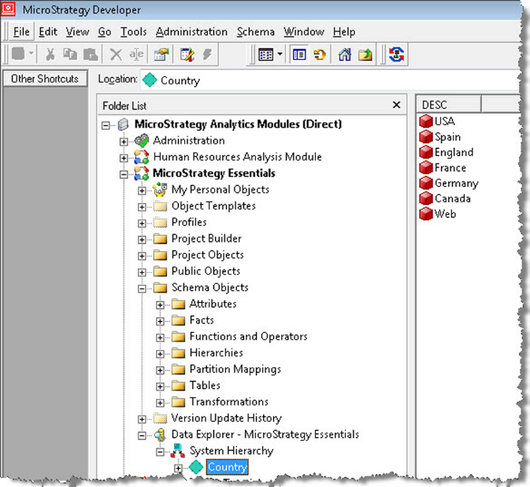

System Hierarchy

The System Hierarchy will show all the Attributes in the project with their relationships and their Attribute elements. The Attribute elements are simply the data inside the lookup tables. It is important to note that the Attribute elements are **not Objects** but data instead.

The Architect can define **user Hierarchies** and make them available for final users as drill paths to perform data discovery and further analysis on Reports. In the next exercise, we will learn how to create a user Hierarchy.

**Exercise – Creating user Hierarchies**

In this exercise you will learn to create Hierarchies.

1. Open your new project MicroStrategy Essentials and go to the Schema Objects | Hierarchies | Data Explorer folder.

*Note: you can save a Hierarchy in any other folder. However, to make the Hierarchy available inside Data Explorer it must be saved in the above location.*

1. Right-click New | Hierarchy.
2. On the Select Objects window, shown as follows, select Call Ctr, Country and Region | OK:

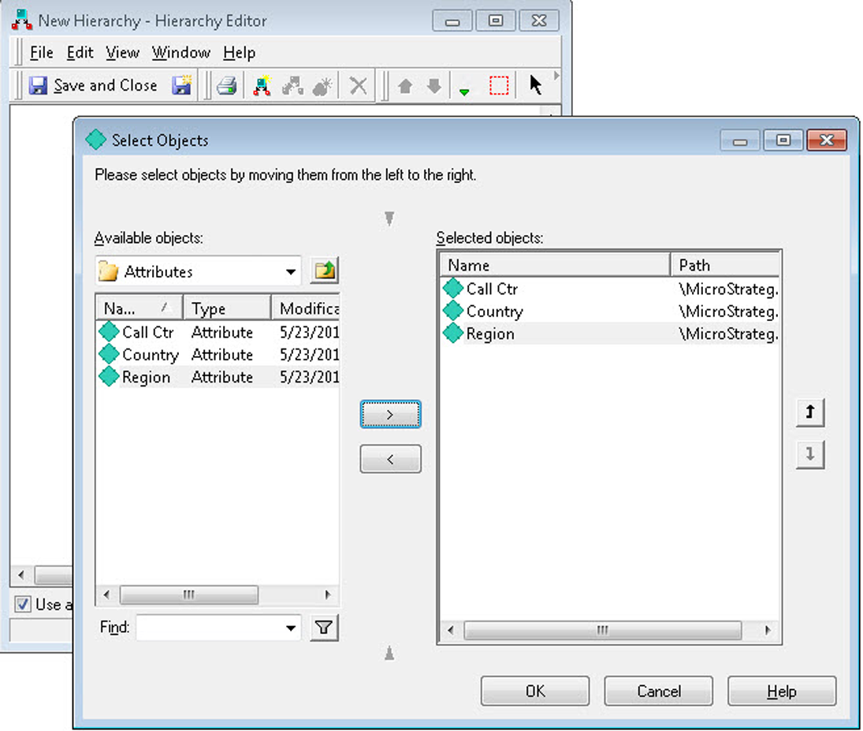

Select Objects window

1. The highest-level Attribute will be selected as **entry point**. In other words, the Attribute with no parents will have a green check mark that indicates a user will be able to drill from it as a starting point. This behavior can be modified by right-clicking the desired Attribute and Set as entry point. Note the following screenshot:

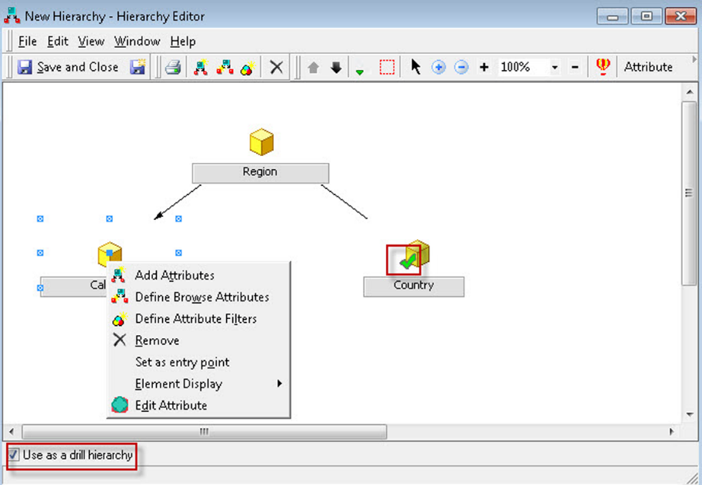

Setting an Attribute as entry point

1. To use this Hierarchy in Reports as a drill path, check Use as drill Hierarchy | Save and Close.
2. Name your Hierarchy as Geography | Save | update schema.
3. Navigate to the Data Explorer (not the folder but the visualization tree instead) and if you don't see your Hierarchy, hit *F5*. Expand your Geography Hierarchy to reveal the Attribute relationships and elements, shown as follows:

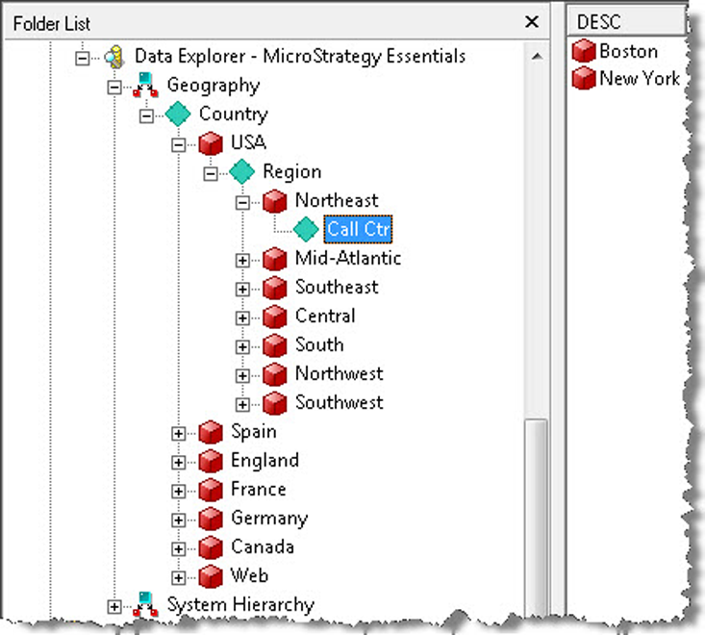

Attribute relationships and elements

1. This finalizes the exercise.

# Comparing data across time – Transformations

Transformations are objects that are used inside Metric definitions (we will cover Metrics in the following chapters) to map a time period to another offset time period. The following is a quick reference table for this MicroStrategy Object:

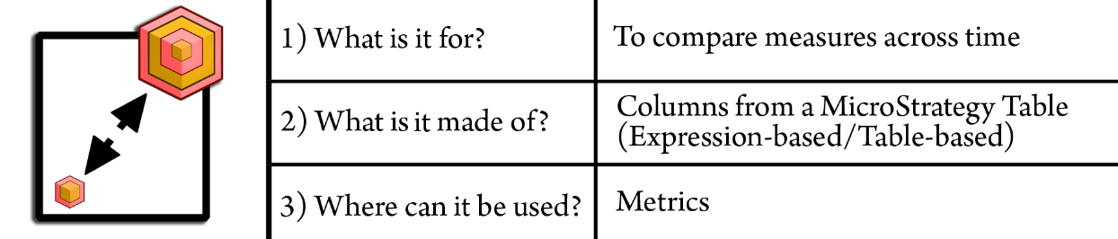

This object will allow users to perform comparisons between different times, such as this month versus last month, or this year versus last year.

Transformation could be defined using an offset calculation or formula. For example, YEAR -1 to define last year. However, due to the complexity and dynamism of some calendars such as 4-5-4 calendars, it is recommended to use database tables (Transformation tables) to define how a current time Attribute should be mapped.

You can check how table-based Transformations are created by navigating to MicroStrategy Tutorial project | Schema Objects | Transformations and opening any transformation. For example, the Previous Transformation, shown as follows:

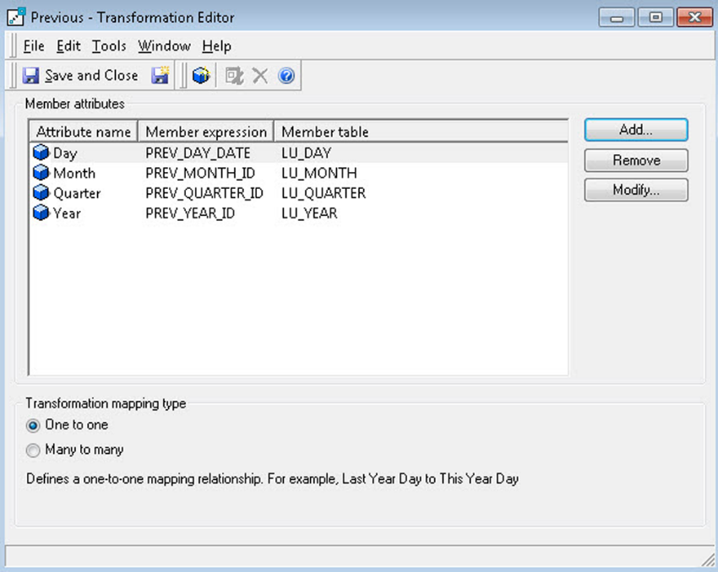

Checking table-based Transformations

You can see this Transformation has four Attribute members, each one with its corresponding transformation expression and where this expression is pulled from. When this Transformation is added to a Metric (such as sales), it will calculate the aggregation not to the actual time but instead using the Transformation expression.

**Summary**

At the end of this chapter, you should be able to differentiate the three main object types or categories. You should be familiar with the MicroStrategy Developer interface and default Project structure. At this point you should understand and be able to create the following objects:

**Configuration Objects**:

* Project

**Schema Objects**:

* Table
* Fact
* Attribute
* Hierarchy
* Transformation

In the next chapter, we will create and manipulate our first Report but not before understanding some of its component objects: Templates, Filters, and Metrics.